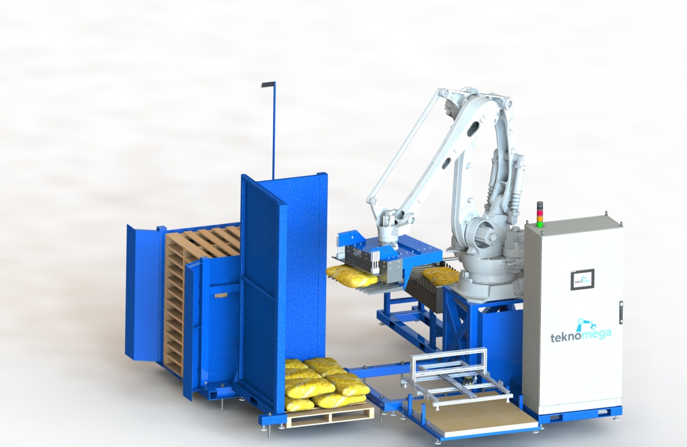

Palettiser

Compak

* Low Cost
* Small Footprint 16 feet long x 16 feet wide x 12 feet high
* Load Up to 100kg
* Automatic empty pallet loading
* Corner Stacking for bags; gives more squareness to the pallet
* Mid pallet loading (for two pallets on top of each other)
* Sheet separator for Canada Gap regulation (optional)

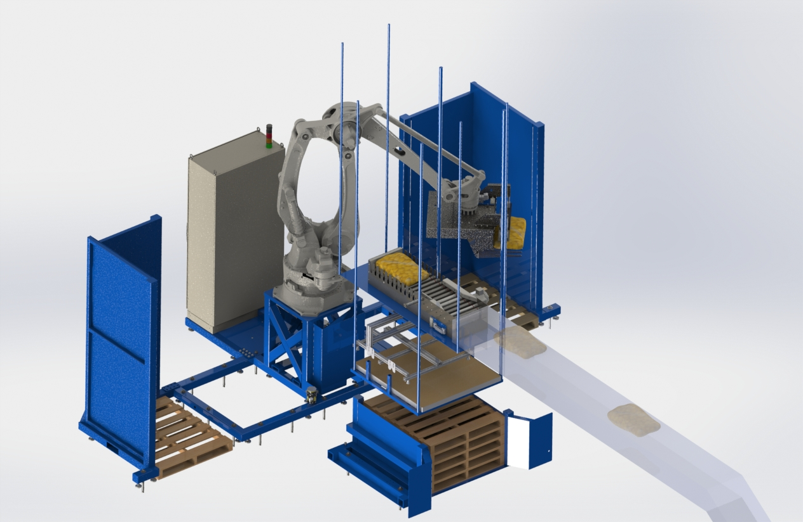

Palettiser

Double

* Low Cost
* Palletize on both sides. Faster palettizing
* Load Up to 100kg
* Automatic empty pallet loading
* Corner Stacking for bags; gives more squareness to the pallet
* Mid pallet loading (for two pallets on top of each other)
* Sheet separator for Canada Gap regulation (optional)

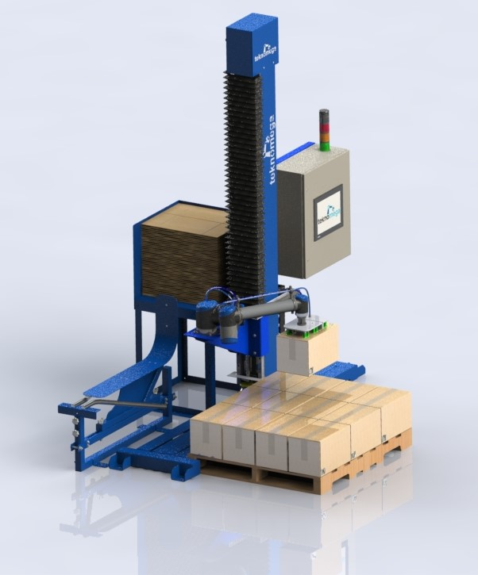

Palletiser - Collaborative

Simple with Case Erector

* Palletize on one side and a Case Erector on the other side
* Load Up to 15kg
* Collaborative: No fence needed
* Can stack as 8 feet high
* Capable of doing another task in front of him

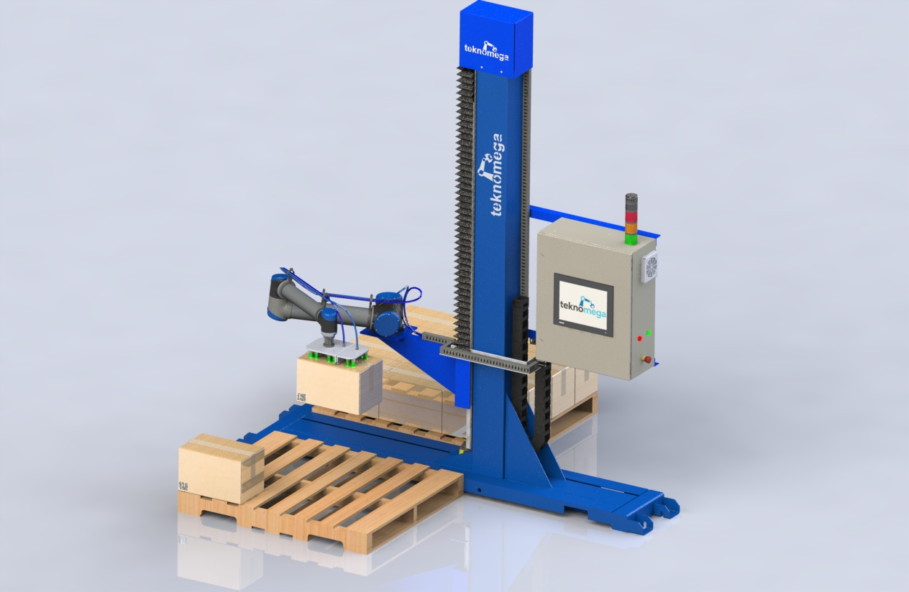

Palletiser - Collaborative

Double

* Palletize on both Side
* Load Up to 15kg
* Collaborative: No fence needed
* Can stack as 8 feet high
* Capable of doing another task in front

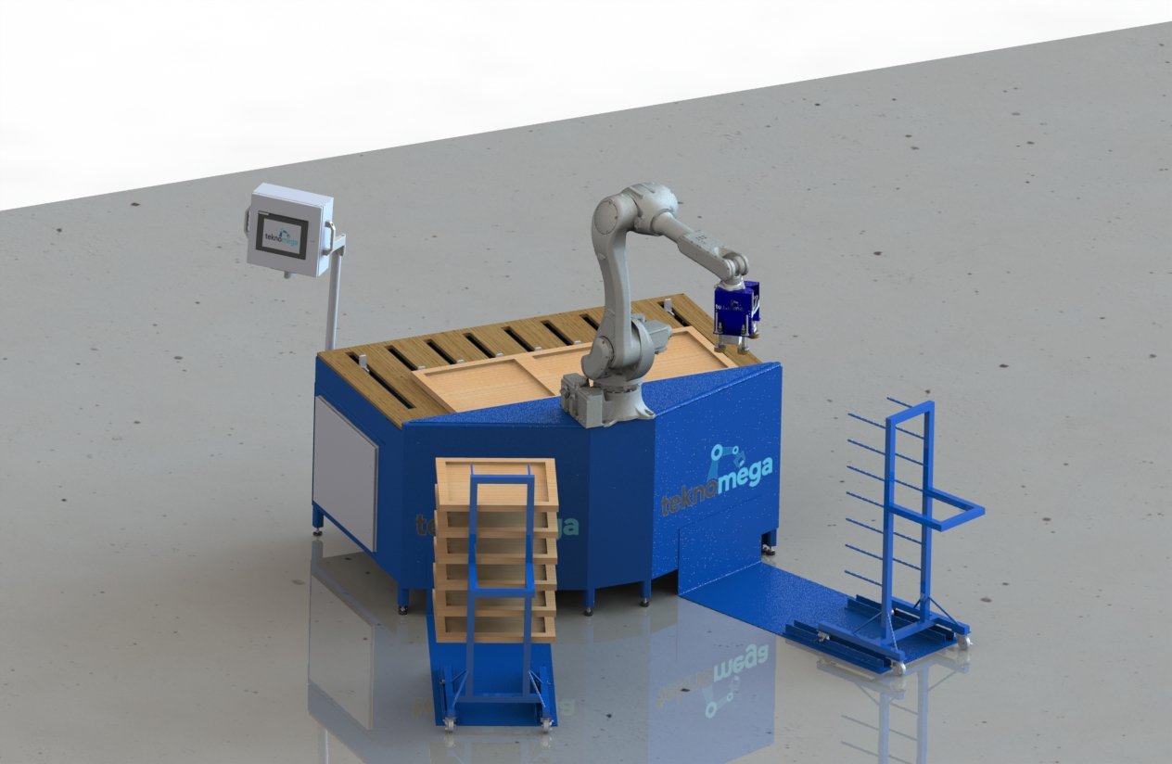

SANDER

* Self-Loading. No employee needed
* Up to 42 x 36-inch door size
* High Speed Adjustable Pressure sanding
* Four different sanding patterns including a weaving pattern.
* Easy of use HMI
* Collaborative option

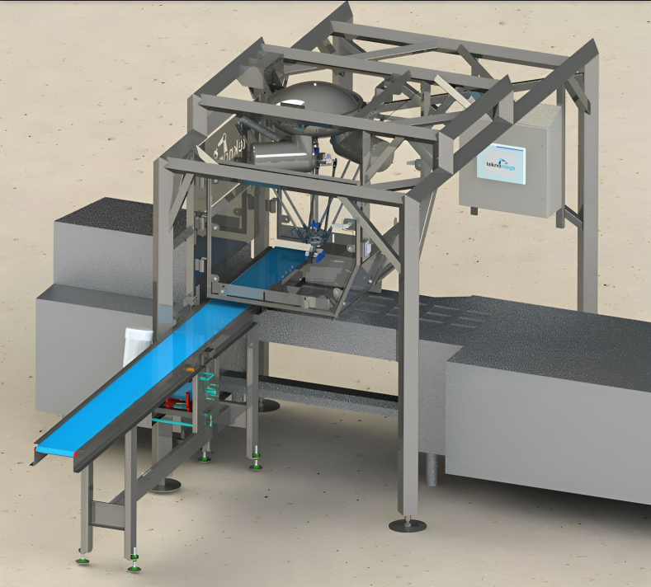

Pick & Place

Delta Robot IP69 (Sanitary)

* Capable of 60 picks per minute
* Paired with a Camera Vision for product orientation
* Robot Controller: Allen-Bradley PLC and HMI.
* Capable of controlling other equipment such as conveyor, upward and downward machine.

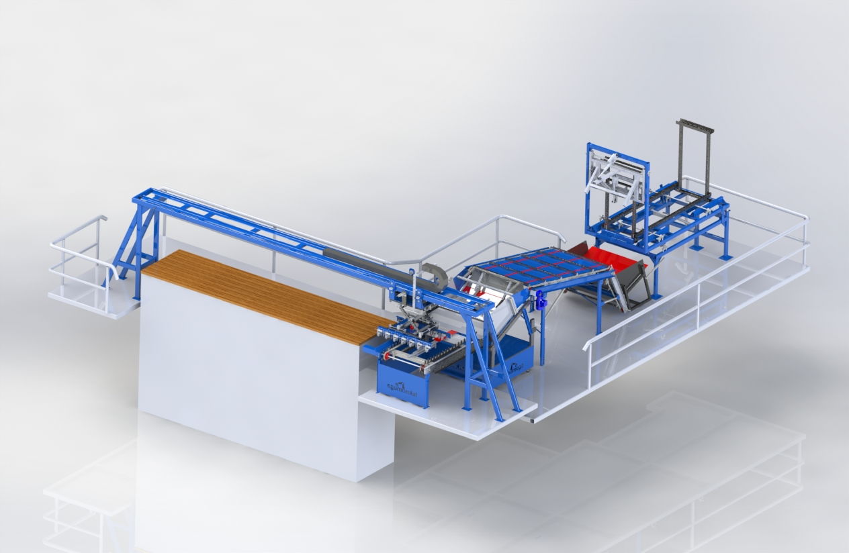

Wood Stick Spacer Stacker

* Place wood stick between row of Hardwood
* Two cycles of 13 sticks per minute
* Wood stick singularizer

Call us for more information and guidance:

[450-914-1036](tel:4509141036)